II INTERNATIONAL COMPETITION OF VISUAL ARTS
SOLVING THE MYSTERY OF PAINTER ĢEDERTS ELIASS

Every generation has its own tasks. In the field of culture – to identify, explore and preserve the intellectual pearls of our ancestors. Without history there is no future, so it is important to know and honour the personalities of your nation.
One of those in the Latvian culture of 20th century was Ģederts Eliass – a bright painter, a researcher of art history, a strong personality whose artistic heritage proves belongingness to the highest European cultural qualities. We are proud that this outstanding personality was born and grown up in Zīlēni, estate situated in Platone parish, Jelgava Local Municipality.

Music and Art school of Jelgava Local Municipality organizes the second competition of visual arts devoted to diverse art styles and genres of Latvian artist Ģ. Eliass.

REGULATIONS OF THE COMPETITION

COMPETITION ORGANIZER
Music and Art school of Jelgava Local Municipality
VENUE
Jelgava Local Municipality, Latvia
DEADLINE FOR SUBMISSION OF COMPETITION WORKS
12th March 2019
ADDRESS
Skolas street 2, Nākotne, Glūda parish, Jelgava Local Municipality, Latvia, LV-3040

SUPPORTERS OF THE COMPETITION
Jelgava Local Municipality
Jelgava History and Art museum named after Ģ. Eliass
“Laflora”, Ltd.
THE AIM OF THE COMPETITION
To promote awareness of children and young people and to promote their interest about the still life as the genre of art. To develop composition from different objects and nature gifts, to reproduce them in the art work.
TASKS OF THE COMPETITION
- To promote the development of students' creative thinking and to develop practical skills in painting, graphics, computer graphics and photography in the genre of still life.
- To promote collaboration between the cooperation partners of Jelgava Local Municipality, get acquainted with new partners; get acquainted with their culture, traditions and people.
- Create opportunities for sharing experiences for children and young people, teachers and artists in order to get new friends, partners and ideas.

THEME OF THE COMPETITION
Still life. Nature gifts. Art work, that reproduces wildlife (fruits, vegetables, flowers, game) and inanimate nature (household items, crockery etc.) objects arranged in composition.

PARTICIPANTS OF THE COMPETITION
Students of art education institutions and interest education programs.

AUTHOR OF THE COMPETITION WORK
Individual persons

FORMAT OF THE COMPETITION WORK
Only original works are accepted for the competition, participants submit only two-dimensional works - A3 format (30x42), A2 format (42x60cm). Computer graphics and photography must be printed on A4, A3, or A2 format. Lay-out requirements are given in the Annex.

EVALUATION CRITERIA FOR COMPETITION WORKS*
*Only individual works will be evaluated in the competition

- Compliance with the competition theme.
- The originality of idea (harmony of composition, colors, elements).
- Artistic and technical performance, lay-out of the work.

AGE GROUPS OF PARTICIPANTS
Children and young people aged 7 – 18 are invited to take part in the competition.
Age groups:
- 7-9 years old
- 10-12 years old
- 13-15 years old
- 16-18 years old

techniques of the works
- Painting
- Graphics
- Computer graphics
- Photography

JURY OF THE COMPETITION
Works will be evaluated by an international jury composed of professional artists. The jury commission is approved by the organizers of the competition. The first, second and third place is awarded in each category and age group. The jury has rights to award promotional prizes, to set the competition`s Grand Prix. An audience prize can be awarded, as well as other awards. The jury reserves rights to change the prize distribution by categories.

SUBMISSION OF WORKS TO THE COMPETITION

The deadline – 12th March, 2019 (postal stamp)

AWARDING OF COMPETITION WINNERS

During the festive event on 25th April, 2019 at 14:00pm in the Jelgava History and Art museum named after Ģ. Eliass, Akadēmijas street 10, Jelgava, Latvia

OTHER REGULATIONS
1. Competition organizers can use the competition works to create a traveling exhibition, for different kind of presentations, to publish in newspapers and magazines, referring to the author of the work, in accordance with the requirements of the normative acts of the Republic of Latvia.
2. During the event participants may be photographed or filmed, photographs and audiovisual material may be made public for non-commercial purposes.
3. Receiving of awarded, but not received on-site prizes, appreciation and recognition diplomas shall be agreed with the organizers of the competition.
4. The application for a competition confirms that the participant's representative agrees to these terms and conditions.

CONTACT INFORMATION OF THE COMPETITION ORGANIZERS
- Dace Laure Director of Music and Art school of Jelgava Local Municipality
Address: Skolas street 2, Nākotne, Glūda parish, Jelgava Local Municipality, Latvia, LV-3040
Phone: +371 63077160; mobile +371 28318526
e-mail: jnmms@jelgavasnovads.lv
- Liene Āboma Methodologist of Music and Art school of Jelgava Local Municipality
Address: Skolas street 2, Nākotne, Glūda parish, Jelgava Local Municipality, Latvia, LV-3040
Phone: +371 63077160; mob. +371 26418317
e-mail: jnmms@jelgavasnovads.lv

We wish you good luck!
Thank you for your responsiveness!

ANNEX
TO BE FILLED IN WITH LATIN BLOCK CAPITALS!
CARD No 1*
* to be fasten with glue on the BACK SIDE of the work

NAME, SURNAME OF THE AUTHOR:…………………………………………………………..…………………

AGE:…….YEARS OLD
SCHOOL:……………………………………………………………
ADDRESS:……………………………………………………………………………….

PHONE:………………………………
E-MAILS:……………………………………….
TEACHER:……………………………………………………………………
PHONE:………………………
E-MAIL:…………………………

INFORMATION ABOUT ARTISTIC WORK:
TITLE: ...………………………………………………………………………
TECHNIQUE: painting □ graphics □
computer graphics /photography □

CARD No 2*
*turned-down

Place for glue

-----------------------------------------------------------------------------------------------------------

NAME, SURNAME OF THE AUTHOR: …………………………………………………………

AGE:…….YEARS
TITLE OF THE WORK:...…………………………………….………………………...
SCHOOL:...……………………………………………………………..........................
TEACHER: ...……………………………………………………………..................

LAY-OUT OF THE WORK
CARD No 1 should be fasten with glue on the BACK SIDE of the work

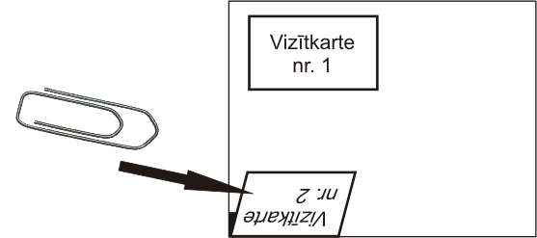
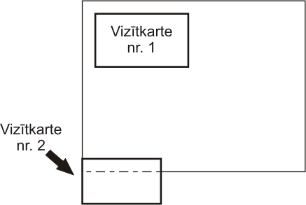
BACK SIDE BACK SIDE

CARD No 2 should be turned-down to the back and pinned up (in order to evaluate works anonymously). It will be un-folded during the exhibition.

